Plowing ahead with a green fleet

Some new, innovative vehicles are clearing the roads and responding to emergencies in southern Ontario this winter. Oxford County has rolled out some new first-in-Canada fleet technology that will help the community reduce its carbon emissions.
Two snowplows, powered by compressed natural gas (CNG) are clearing and treating County roadways on the periphery of the City of Woodstock this winter. Two new hybrid ambulances with solar panels and anti-idling technology have been deployed to active duty with Oxford County Paramedic Services.
The new additions are part of a larger green fleet plan by the County that includes CNG-hybrid light trucks, and electric vehicles including a Chevrolet Volt and Bolt. The County was also exploring the option of piloting a CNG-hybrid waste management collection vehicle at the time of publication.
The enhancements being made to the County’s fleet are projected to achieve a 6.2% reduction in CO2 emissions per year. That would be the equivalent to keeping 38 barrels of oil in the ground, or preserving 19 acres of forest; and this is just the beginning.
Snow plow operator Brad Archer prepares to board Oxford County’s new CNG snow plow

Compressed Natural Gas (CNG) snow plows
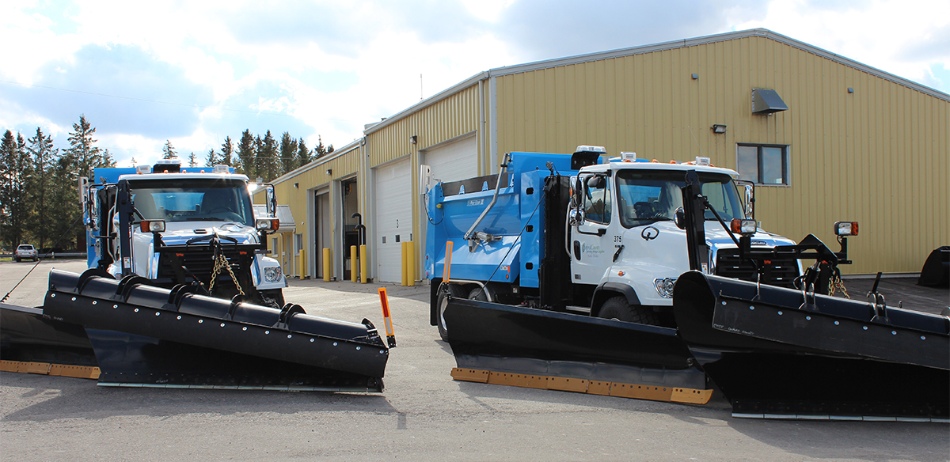
Oxford County’s manager of Engineering Services, Melissa Abercrombie, says it was like Christmas came early for the Woodstock Patrol Yard when the new CNG snow plows arrived in late October. There’s always some excitement when a new “toy” arrives for Public Works operators to start using out in the field. But Abercrombie says there was an added buzz in the air when the shiny white and “New Brunswick Blue” trucks arrived. “Anytime you can introduce a Canadian-first, especially something as iconic as a snow plow, it is really exciting for our roads crew. They’re excited to see how the CNG plow will perform under the harsh winter conditions. These are heavy-duty vehicles that are used for long hours, so being able to provide this important service and while mitigating our environmental impact gives us a great feeling.”
CNG is the cleanest burning transportation fuel on the market today, producing 20-30% fewer greenhouse gas emissions and 95% fewer tailpipe emissions than petroleum products. The CNG plows have a similar 550 kilometer range under optimal conditions, equivalent to an 80 gallon diesel tank.
Making the move to CNG fleet vehicles has been made possible by a unique partnership with Woodstock-based Rural Green Energy. They are the natural gas provider with a 3600psi fill station just outside of Woodstock where the County’s fleet vehicles can fill up on natural gas at any time of day with 24/7 commercial access. The company is also working on a biogas project that would take animal waste from local agricultural operations and convert it to renewable natural gas (RNG) through anaerobic digestion (bringing a new meaning to the term horse power).
However, the only limitation to converting vehicles to CNG is that Rural Green Energy is the only fill station in Oxford County. With over 600 kilometers of roadway to service, logistically, it only makes sense to deploy the CNG snow plows to a few select routes around the city.

Electric hybrid ambulances

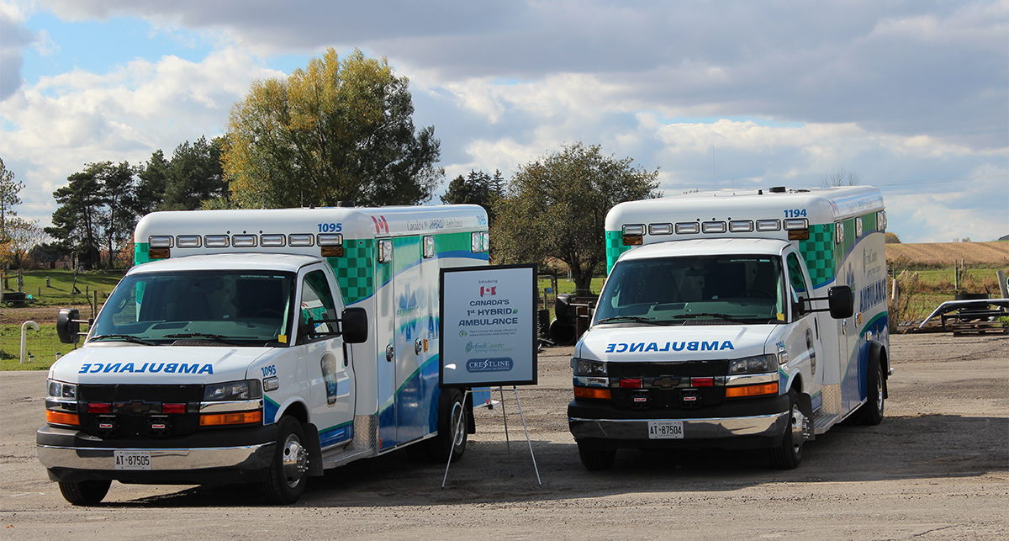
Canada’s first electric hybrid ambulances were first debuted at the Ontario Association of Paramedic Chiefs conference in Ottawa in late September. From the outside, the two Fleetmax XL3 hybrid ambulance would appear to look like any other ambulance, but it is the technology within that makes them truly innovative vehicles. First, a regenerative braking system will increase fuel economy by converting the vehicle’s kinetic energy into chemical energy that is stored in the battery. This will help increase fuel economy by 25% and reduce fuel costs by 20%.
Additionally, a flat solar panel attached to the roof of the ambulance harnesses the power of the sun, supplying energy to onboard batteries and working in tandem with the anti-idling Eco-Run system. Oxford County Paramedic Chief Ben Addley explains how it works, “By nature of the job, ambulances are often left idling. A crew may be at a community event or a location waiting to be dispatched to a call, and even at a call when Paramedics are working on scene, the vehicle may be left sitting idle. What the Eco-Run system does, is it will shut the engine off when that ambulance is idling, but it draws on energy from batteries to supply a continuous stream of power to the medical equipment and climate system. This allows the inside temperature to remain steady without burning fuel and releasing that carbon into the atmosphere. It’s really an amazing integration of technology.”
Chief Addley says the idea of reducing unnecessary pollution is being embraced by Oxford’s team of Paramedics. “As first responders, we know our creating a healthier environment will help create healthier residents — we see the impact of asthma, heart attacks, and strokes every day. So if there is new technology that will help reduce our environmental impact without compromising patient care and the ability to respond, we are all for it.”
The electric hybrid ambulance was manufactured by Saskatoon-based Crestline Coach in conjunction with Acetech Canada, who supplied the Eco-Run system.

What’s next?
Looking forward, there are still a number of challenges in greening the County’s fleet of 119 vehicles. Access to CNG fueling stations and the limited range of electric vehicle batteries are just two obstacles in serving a small urban/rural mix County covering over 2000 square kilometers.
But as the old adage goes, where there’s a will, there’s a way. Oxford County Warden David Mayberry believes the new green fleet vehicles are just an initial step towards a cleaner, greener future, “We’re on a journey that our County Council has set to achieve 100% renewable energy by the year 2050. We know it’s going to be baby-steps along the way. We need the support of our staff and our suppliers who are willing to take that journey with us. Whether it’s converting a truck to run on CNG instead of diesel, or putting a solar panel on the roof on an ambulance, they are all first steps. I know there will be future steps and I hope we can do so in tandem with our suppliers. As we collect the data from these vehicles, we will relay that information to our suppliers so they know what we need to do better next time so we can take that next step in the journey.”

Article by Adam Nyp, Communications Advisor, Oxford County
anyp@oxfordcounty.ca | 519-539-9800 ext. 3529
For technical inquiries contact:
Melissa Abercrombie, Manager of Engineering Services, Oxford County
mabercrombie@oxfordcounty.ca | 519-539-9800 ext. 3131

