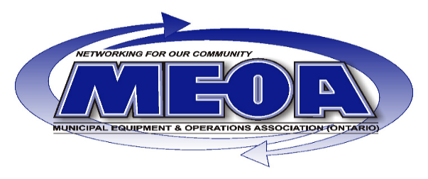

24thAnnual Technology Field Trip Sept 22 to Sept 27
SPONSORS
ITINERARY OVERVIEW: COST: $599.00 + HST
MACK HAGERSTOWN POWERTRAIN PLANT HIGHLIGHTS
- STATE OF THE ART ENGINE & TRANSMISSION ASSEMBLY PLANT TOUR
- NEW EQUIPMENT AND TECHNOLOGIES:
- NEXT GENERATION EMISSION LEVEL COMPLIANCE ENGINES
- MACK MDRIVE WITH CREEPER GEARS FOR USE IN PAVING, ROAD REPAIRS AND OFF ROAD APPLICATIONS
- ROCK FREE AND POWER LAUNCH FEATURES TO AVOID CLUTCH, DIFFERENTIAL AND TRANSMISSION DAMAGE
- NEW SPLIT SHAFT OPTIONS FOR PTO AND AUXILIARY EQUIPMENT
ALLENTOWN MACK TRUCK ASSEMBLY PLANT & CUSTOMER CARE CENTRE HIGHLIGHTS
- PLANT TOURS, SHOWCASE SAFETY STANDARDS AND ENVIRONMENTAL SAVINGS
- MUNICIPAL TRENDS AND NEW PRODUCTS
- ALL NEW MACK BELLY SNOW PLOW CONFIGURATIONS
- BODY BUILDER SUPPORT PROGRAMS
- MACK MUNICIPAL EXPERT ON HAND THROUGHOUT FOR ANY Q&A
- NEW EQUIPMENT AND TECHNOLOGIES:
- UPTIME SOLUTIONS - OVER THE AIR ENGINE/TRANSMISSION SOFTWARE PROGRAMMING
- COST OF OWNERSHIP AND FUEL EFFICIENCY ANALYTICAL TOOLS
- RIDE AND DRIVE MACKS CURRENT MODEL LINE UP ON MACK TEST TRACK
VOLVO DAYS PLANT TOURS AND CUSTOMER CARE CENTRE HIGHLIGHTS
- MACHINE SHOW & PLANT TOURS
- SAFETY TALK AND INTRODUCTION OF NEW SAFETY FEATURES
- SPEAK WITH NORTH AMERICAN EQUIPMENT SPECIALISTS
- NEW EQUIPMENT & TECHNOLOGIES:
- NEXT GENERATION EMISSION LEVEL COMPLIANCE ENGINES
- DISCONTINUED USE OF DIESEL POWERED COMPACT EQUIPMENT AND INTRODUCTION OF PROTOTYPE ELECTRIC SOLUTIONS
- REAL TIME FLEET MONITORING, SERVICE IMPROVEMENTS INCLUDING HYDRAULIC TILTABLE CABS
- RIDE AND DRIVE VOLVO CURRENT MODEL LINE UP ON VOLVO TEST TRACK
- INCLUDING; LC450 WASTE COMPACTOR, NEW 6/15/17 TON SHORT RADIUS WHEELED EXCAVATORS, AND ALL ROAD MAINTENANCE MACHINES
Please contact RICK ELLIG @ 519-580-1069 OR rellig@regionofwaterloo.ca if interested in attending. Spots are limited and registration and payment of the trip can be made @ the MEOA website http://meoa.org/ from June 1st – June 30th 2019.

