2022 PD Day
Thursday May 26th

The MEOA Executive looks forward to reconnecting in person once again

2022 Golf PD Day will kick off our 2022 events Thursday May 26th, 2022 at;

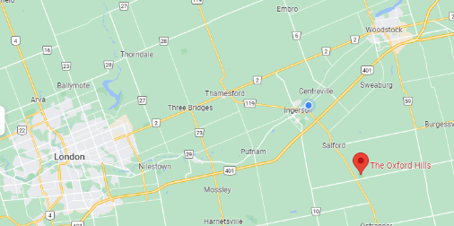
The Oxford Hills,
324183 Mt. Elgin Rd.
Mount Elgin, ON N0J 1N0
www.theoxfordkills.ca
approx. 10mins south of the 401
exit 218 Plank Line/ON 19 Ingersoll
Registration: 09:00
Shotgun Start: 10:00
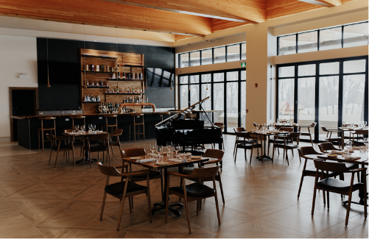
Dinner: approx. 16:00

Included in your All-In-1 Membership
or Member PD Day $150
Guests PD Day $185

Go to https://www.meoa.org/store/ to
purchase or update your 2022 membership
or register for events
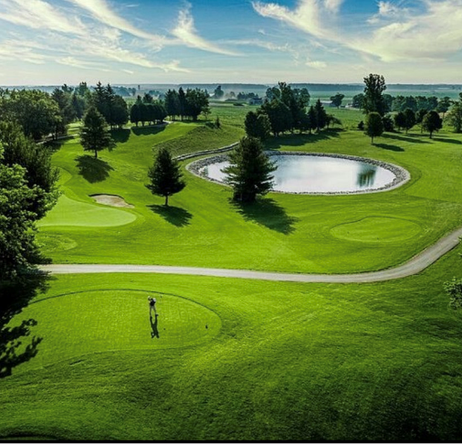
(Registrations for cancelled 2020 & 2021 events will be honoured for 2022 events)

If you would like to arrange specific partners or 4-somes, please contact 1 of your
PD Day Committee members
Bill Koch bkoch@viking-cives.ca
Trent Crowe trent.crowe@welland.ca
Stephen Sinclair stephen.sinclair@kitchener.ca

2022 Charity recipients

We look forward to seeing you all there

