

**26thAnnual Technology Field Trip Sept 29 to Oct 3rd, 2024**

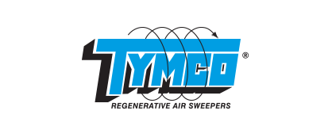**MAJOR SPONSORS**

***THE EQUIPMENT SPECIALIST INC***

**FIELD TRIP ITINERARY OVERVIEW – LOCATION: WACO TEXAS USA**

**TYMCO EQUIPMENT HIGHLIGHTS**

* PLANT TOUR
* NEW EQUIPMENT AND TECHNOLOGIES
* TEST TRACK AND EQUIPMENT DEMOS
* MUNICIPAL CONFERENCE – Waco Texas Municipality

**CITY OF WACO OPERATIONS MEETING HIGHLIGHTS**

* PRESENTATIONS AND DISCUSSIONS “CHALLENGES AND SUCCESSES”
* FLEET MANAGEMENT
* STORM WATER MANAGEMENT

**TEXAS CIVIL ENGINEERING COMPANY HIGHLIGHTS**

* HEAVY EQUIPMENT WASHOUT FACILITY DESIGN
* FILTER TREATMENT SYSTEM DESIGN
* CAPTURE AND CONTAINMENT

**ADDITIONAL SPONSORS SUPPORTING THE MEOA FIELD TRIP INCLUDE**

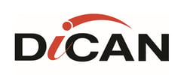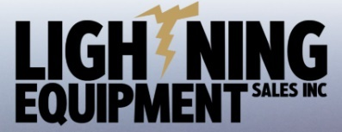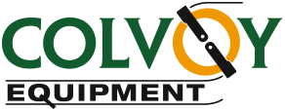

**MANY THANKS TO ALL SPONSORS SUPPORTING OUR ANNUAL TECHNOLOGY FIELD TRIP!!!**

**COST: $1099.00 + HST**

Municipal members interested in attending or Supplier members interested in sponsorship of this event,

please contact RICK ELLIG @ 519-580-1069 [rnick669@gmail.com](mailto:rnick669@gmail.com)

Spots are limited and registration and payment of the trip can be made @ the MEOA website <http://meoa.org/>.

**Registration must be submitted by end of August! The full itinerary and Flight information will be made available early September for all registrants.**

**NOTE: If you are unable to reach Rick, please contact any of the MEOA executive.**